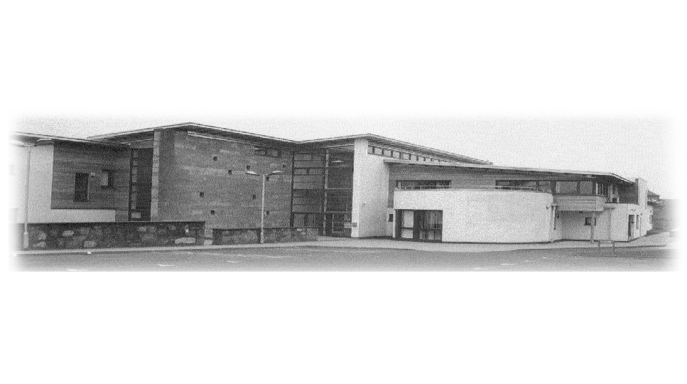

Dr Rebecca Wheater West Practice

Dr Giles Ledlie Springfield Medical Centre

Dr Andrew Forrester 30 Ponderlaw Street

Dr Craig Nicoll Arbroath DD11 1ES

Dr Raquel Romero-Perez Tel 01241 870307

Data Protection Notice

- About the personal information we use
West Practice, Springfield Medical Centre use personal information on different groups of individuals including:

- Patients
- Staff
- Contractors
- Suppliers
- Complainants, enquirers
- Survey respondents
- Professional experts and consultants
- Individuals captured by CCTV
The personal information we use includes information that identifies you like your name, address, date of birth and postcode.
We also use more sensitive types of personal information, including information about racial or ethnic origin; political opinions; religious or philosophical beliefs; trade union membership; genetic data, health; sex life or sexual orientation.
The information we use can relate to personal and family details; education, training and employment details; financial details; lifestyle and social circumstances; goods and services; visual images; details held in the patient record; responses to surveys.

- Our purposes for using personal information
Under the National Health Service (General Medical Services Contracts) (Scotland) Regulations 2018, West Practice, Springfield Medical Centre are contracted to provide continuing, comprehensive, co-ordinated and person centred healthcare to patients in their communities. We undertake these tasks so that we can help to promote the improvement of the physical and mental health of our patients.
We use personal information to enable us to provide healthcare services for patients, supporting and managing our employees; maintaining our accounts and records and the use
of CCTV systems for crime prevention.

- Our legal basis for using personal information
West Practice, Springfield Medical Centre, as data controller, is required to have a legal basis when using personal information. West Practice, Springfield Medical Centre considers that performance of our tasks and functions are in the public interest. So when using personal information our legal basis is usually that its use is necessary for the performance of a task carried out in the public interest, or in the exercise of official authority vested in us. In some situations we may rely on a different legal basis; for example, when we are using personal information to pay a supplier, our legal basis is that its use is necessary for the purposes of our legitimate interests as a buyer of goods and services. Another example would be for compliance with a legal obligation to which West Practice, Springfield Medical Centre is subject to, for example under the Public Health etc (Scotland) Act 2008 we are required to notify Health Protection Scotland when someone contracts a specific disease.
When we are using more sensitive types of personal information, including health information, our legal basis is usually that the use is necessary:
- for the provision of health or social care or treatment or the management of health or social care systems and services; or
- for reasons of public interest in the area of public health; or
- for reasons of substantial public interest for aims that are proportionate and respect people’s rights, for example research; or
- in order to protect the vital interests of an individual; or
- for the establishment, exercise or defence of legal claims or in the case of a court order.
On rare occasions we may rely on your explicit consent as our legal basis for using your personal information. When we do this we will explain what it means, and the rights that are available, to you. You should be aware that we will continue to ask for your consent for other things like taking part in a drug trial.

- Who provides the personal information
When you do not provide information directly to us, we receive it from other individuals and organisations involved in the delivery of health and care services in Scotland. These include NHS Boards including hospitals and primary care contractors such as GPs, dentists, pharmacists and opticians; other public bodies e.g. Local Authorities and suppliers of goods and services.

- Sharing personal information with others
Depending on the situation, where necessary we will share appropriate, relevant and proportionate personal information in compliance with the law, with the following:
- Our patients and their chosen representatives or carers
- Staff
- Current, past and potential employers
- Healthcare social and welfare organisations
- Suppliers, service providers, legal representatives
- Auditors and audit bodies
- Educators and examining bodies
- Research organisations
- Financial organisations
- Professional bodies
- Police forces, Fire Services, Armed Forces
- Central Government
- Insurance Companies

- Transferring personal information abroad
It is sometimes necessary to transfer personal health information overseas for example if you require urgent medical treatment abroad. When this is needed information may be transferred to countries or territories around the world. Any transfers made will be in full compliance with NHS Scotland Information Security Policy.

- Retention periods of the information we hold
Within West Practice, Springfield Medical Centre we keep personal information as set out in the Scottish Government Records Management Health and Social Care Code of Practice (Scotland) 2020. The NHS Code of Practice sets out minimum retention periods for information, including personal information, held in different types of records including personal health records and administrative records.

- How we protect personal information
We take care to ensure your personal information is only accessible to authorised people. Our staff have a legal and contractual duty to keep personal health information secure, and confidential. The following security measures are in place to protect personal information:
- All staff undertake mandatory training in Data Protection and IT Security
- Compliance with NHS Scotland Information Security Policy
- Organisational policy and procedures on the safe handling of personal information
- Access controls and audits of electronic systems

- Your rights

This section contains a description of your data protection rights within West Practice, Springfield Medical Centre.

The right to be informed

West Practice, Springfield Medical Centre must explain how we use your personal information. We use a number of ways to communicate how personal information is used, including:

- This Data Protection Notice
- Information leaflets
- Discussions with staff providing your care

The right of access

You have the right to access your own personal information.

This right includes making you aware of what information we hold along with the opportunity to satisfy you that we are using your information fairly and legally.

You have the right to obtain:
- Confirmation that your personal information is being held or used by us
- Access to your personal information
- Additional information about how we use your personal information

Although we must provide this information free of charge, if your request is considered unfounded or excessive, or if you request the same information more than once, we may charge a reasonable fee.

If you would like to access your personal information, you can do this by contacting:

Gemma Kirkpatrick, Practice Manager, West Practice, Springfield Medical Centre, Arbroath,
DD11 1ES Telephone number: 01241 870307

Once we have details of your request and you have provided us with enough information for us to locate your personal information, we will respond to your request without delay, within one month (30 days). However If your request is complex we may take longer, by up to two months, to respond. If this is the case we will tell you and explain the reason for the delay.

The right to rectification

If the personal information we hold about you is inaccurate or incomplete you have the right to have this corrected.

If it is agreed that your personal information is inaccurate or incomplete we will aim to amend your records accordingly, normally within one month, or within two months where the request is complex. However, we will contact you as quickly as possible to explain this further if the need to extend our timescales applies to your request. Unless there is a risk to patient safety, we can restrict access to your records to ensure that the inaccurate or incomplete information is not used until amended.

If for any reason we have shared your information with anyone else, perhaps during a referral to another service for example, we will notify them of the changes required so that we can ensure their records are accurate.

If on consideration of your request West Practice, Springfield Medical Centre does not consider the personal information to be inaccurate then we will add a comment to your record stating your concerns about the information. If this is case we will contact you within one month to explain our reasons for this.

If you are unhappy about how we have responded to your request for rectification we will provide you with information on how you can complain to the Information Commissioner’s Office, or how to take legal action.

The right to object

When West Practice, Springfield Medical Centre is processing your personal information for the purpose of the performance of a task carried out in the public interest or in the exercise of official authority you have the right to object to the processing and also seek that further processing of your personal information is restricted. Provided we can demonstrate compelling legitimate grounds for processing your personal information, for instance; patient safety or for evidence to support legal claims, your right will not be upheld.

Other rights

There are other rights under current Data Protection Law however these rights only apply in certain circumstances. If you wish further information on these rights click here

The right to complain

West Practice, Springfield Medical Centre designates a Data Protection Officer to check that we handle personal information in a way that meets data protection law. If you are unhappy with the way in which we use your personal information please tell our Data Protection Officer using the contact details below.

Data Protection Officer
Information Governance & Cyber Assurance Team
Maryfield House (South)
30 Mains Loan
Dundee
DD4 7BT

Telephone: 01382 740074 Ext 70311

tay.informationgovernance@nhs.scot

You also have the right to complain about how we use your personal information to the Information Commissioner’s Office (ICO). Details about this are on their website at www.ico.org.uk.

